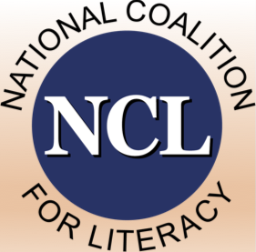 | National Coalition for Literacy

Organization Information Form: Associate Membership

Participation in the National Coalition for Literacy (NCL) is open to all organizations interested in advancing adult education and family literacy in the United States. Membership in the NCL provides opportunities to make a direct impact on issues and to collectively inform decision makers on the needs of the field.

Benefits of Associate Membership
- Visibility: Inclusion in the list of full members on the NCL website, with link(s) to organizational website.
- Networking: Standing invitation to participate in two members’ meetings per year (spring and fall), with opportunities to interact with Congressional and federal agency staff.
- Insight: Standing invitation to participate in monthly policy calls and to interact with other members on the NCL listserv for legislative and other public policy and advocacy news.
- Influence: Opportunities to nominate a representative to serve on the NCL Board of Directors or on a Board committee.

Criteria for Associate Membership
Associate membership is available to the following types of organizations:
- State, regional, and local not-for-profit organizations with a substantial adult education focus (for example, adult basic education, family literacy, high school equivalency assessment and instruction, ESOL, immigration education, prison education)
- For-profit organizations that are interested in supporting and improving adult education and family literacy
- National not-for-profit organizations without a substantial adult education focus but with a strong interest in working with NCL to strengthen adult education
By completing and submitting this form, you agree that your organization meets the criteria listed above.

Annual Dues for Associate Membership
Dues for associate members are assessed on a sliding scale determined by the size of operating budget of the organization or its relevant component.
- Small (up to $250,000): $125
- Medium ($250,001 – $1,000,000): $325
- Large ($1,000,001 or higher: $625
After we receive and process your membership form, we will send you an electronic invoice through QuickBooks. You may pay using the link on the invoice or by mailing a check to National Coalition for Literacy, P.O. Box 2932, Washington, DC 20013.
The membership year is January 1 – December 31.
Organization Name
Organization Mailing Address
 | Street
 | Street Address line 2
 | City, State, Zip
Organization Website (URL)
Organization’s NCL Representative
 | Name
 | Position / Title
 | Email
 | Phone
Organization’s Annual Dues Level |  | $

Submit this form by email to ncl@nationalcoalitionforliteracy.org,
or by postal mail to P.O. Box 2932, Washington, DC 20013.

