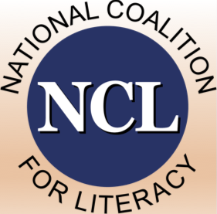 | National Coalition for Literacy

Organization Information Form: Full Membership

Participation in the National Coalition for Literacy (NCL) is open to all organizations interested in advancing adult education and family literacy in the United States. Membership in the NCL provides opportunities to make a direct impact on issues and to collectively inform decision makers on the needs of the field.

Benefits of Full Membership
- Impact: Voting privileges in Board elections and any policy or other major decisions that the Board brings to the voting membership for consideration.
- Visibility: Inclusion in the list of full members on the NCL website, with link(s) to organizational website.
- Networking: Standing invitation to participate in two members’ meetings per year (spring and fall), with opportunities to interact with Congressional and federal agency staff.
- Insight: Standing invitation to participate in monthly policy calls and to interact with other members on the NCL listserv for legislative and other public policy and advocacy news.
- Influence: Opportunities to nominate a representative to serve on the NCL Board of Directors or on a Board committee.

Criteria for Full Membership
Full (voting) membership is available to national not-for-profit organizations whose work is primarily focused on adult education (for example, adult basic education, family literacy, high school equivalency assessment and instruction, ESOL, immigration education, prison education). A national organization that is not primarily focused on adult education but does substantial work in the field will also qualify for full membership if
- It is engaged in work intended to influence adult education public policy at the federal level
- It has a national membership or manages projects that are national in scope and/or it maintains a presence in Washington, DC
By completing and submitting this form, you agree that your organization meets the criteria listed above.

Annual Dues for Full Membership
Dues for full members are assessed on a sliding scale determined by the size of operating budget of the organization or its relevant component.
- Small (up to $250,000): $325
- Medium ($250,001 – $1,000,000): $750
- Large ($1,000,001 or higher: $1,250
After we receive and process your membership form, we will send you an electronic invoice through QuickBooks. You may pay using the link on the invoice or by mailing a check to National Coalition for Literacy, P.O. Box 2932, Washington, DC 20013.
The membership year is January 1 – December 31.
Organization Name
Organization Mailing Address
 | Street
 | Street Address line 2
 | City, State, Zip
Organization Website (URL)
Organization’s NCL Representative
 | Name
 | Position / Title
 | Email
 | Phone
Organization’s Annual Dues Level |  | $

Submit this form by email to ncl@nationalcoalitionforliteracy.org,
or by postal mail to P.O. Box 2932, Washington, DC 20013.

